FILE PERMISSIONS

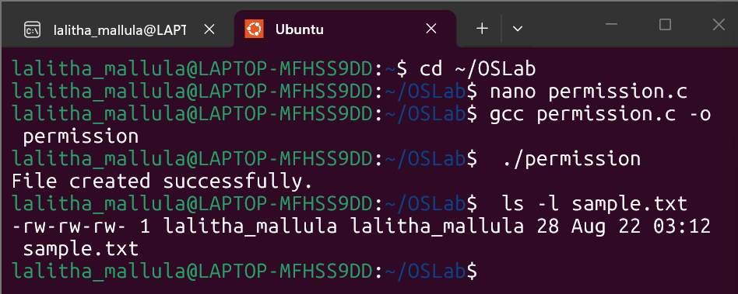

Task 1:
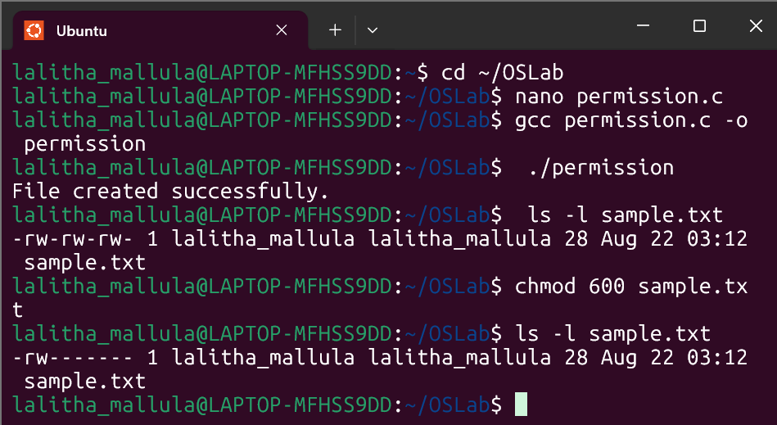
Task 2:
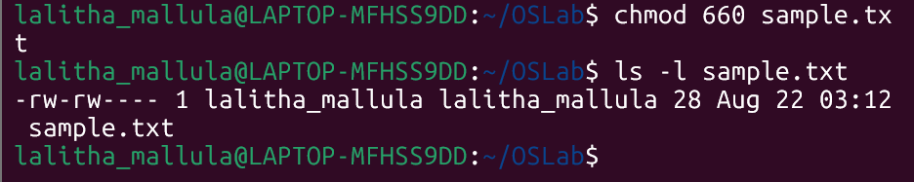
Task 3:
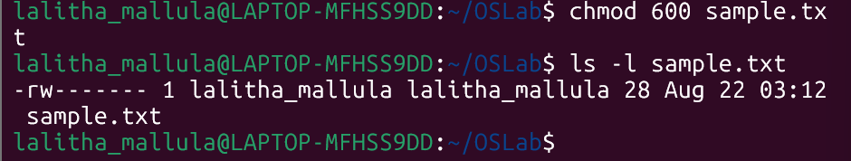

Task 4:
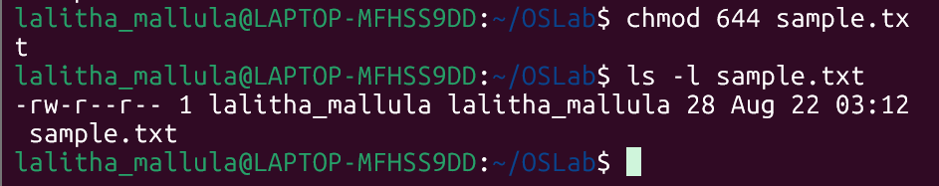

Task 5:
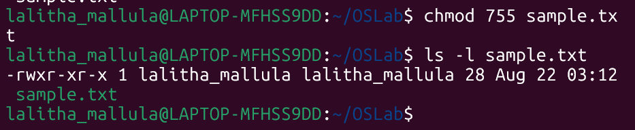

Task 6:
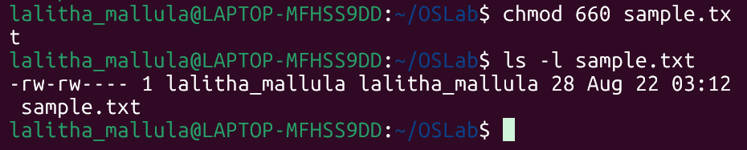

Task 7:
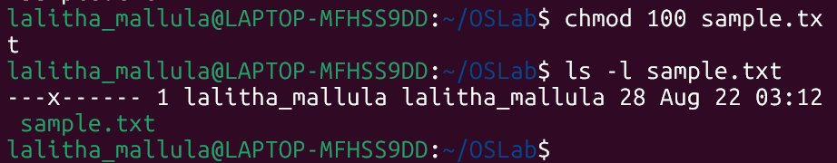

8) Owner: read + write; Group: nothing; Others: nothing → 600
9) Owner: read + write; Group: read; Others: read → 644
10) Owner: read + write + execute; Group: read + execute; Others: read + execute → 755
11) Owner: read + write; Group: read + write; Others: nothing → 660
12) Everyone: read only → 444

